 

|  |
| --- |
| FPT-aptech computer education |
| eProject User Guide |
| Recruitment Process System |
|  |
|  |
|  |

|  |
| --- |
| - Hanoi, 4/2012 - |

1. Login to the system

* 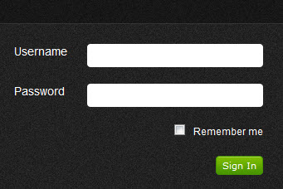Enter user name & password to login
* Some account for testing:

|  |  |  |
| --- | --- | --- |
| Account | Password | Role |
| hr | 123456 | HR Group |
| interviewer | 123456 | Interviewer |

1. Change password

In the first time using the system, you should be changed default password to protect your account

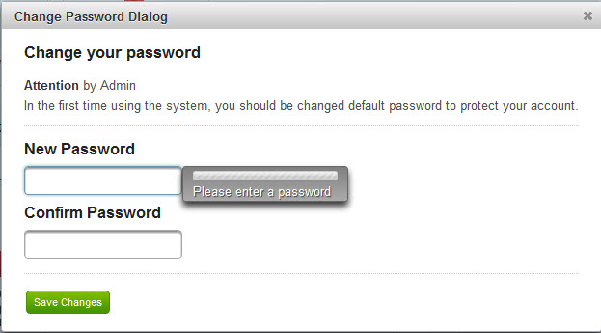

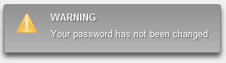The notification will be displayed when you close change password dialog

Or changing password successful

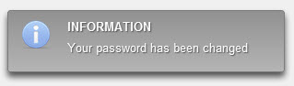

1. Account’s information

This is the quick menu bar, it help you to do the main functions of the system



This is area where display all personal information

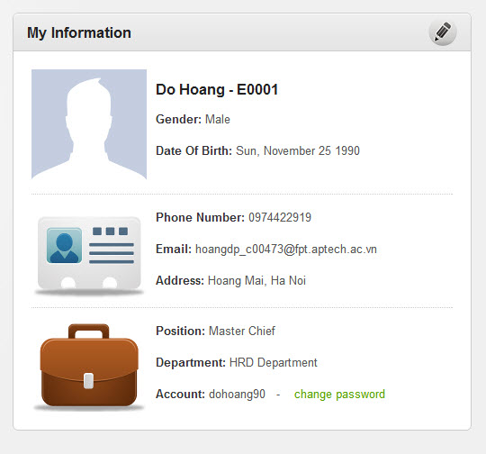

1. Create vacancy

Click the icon to do function “Create vacancy”



Validate form if the data is invalid

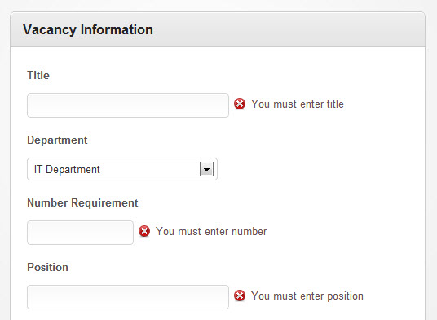

All of the field should be fulfilled

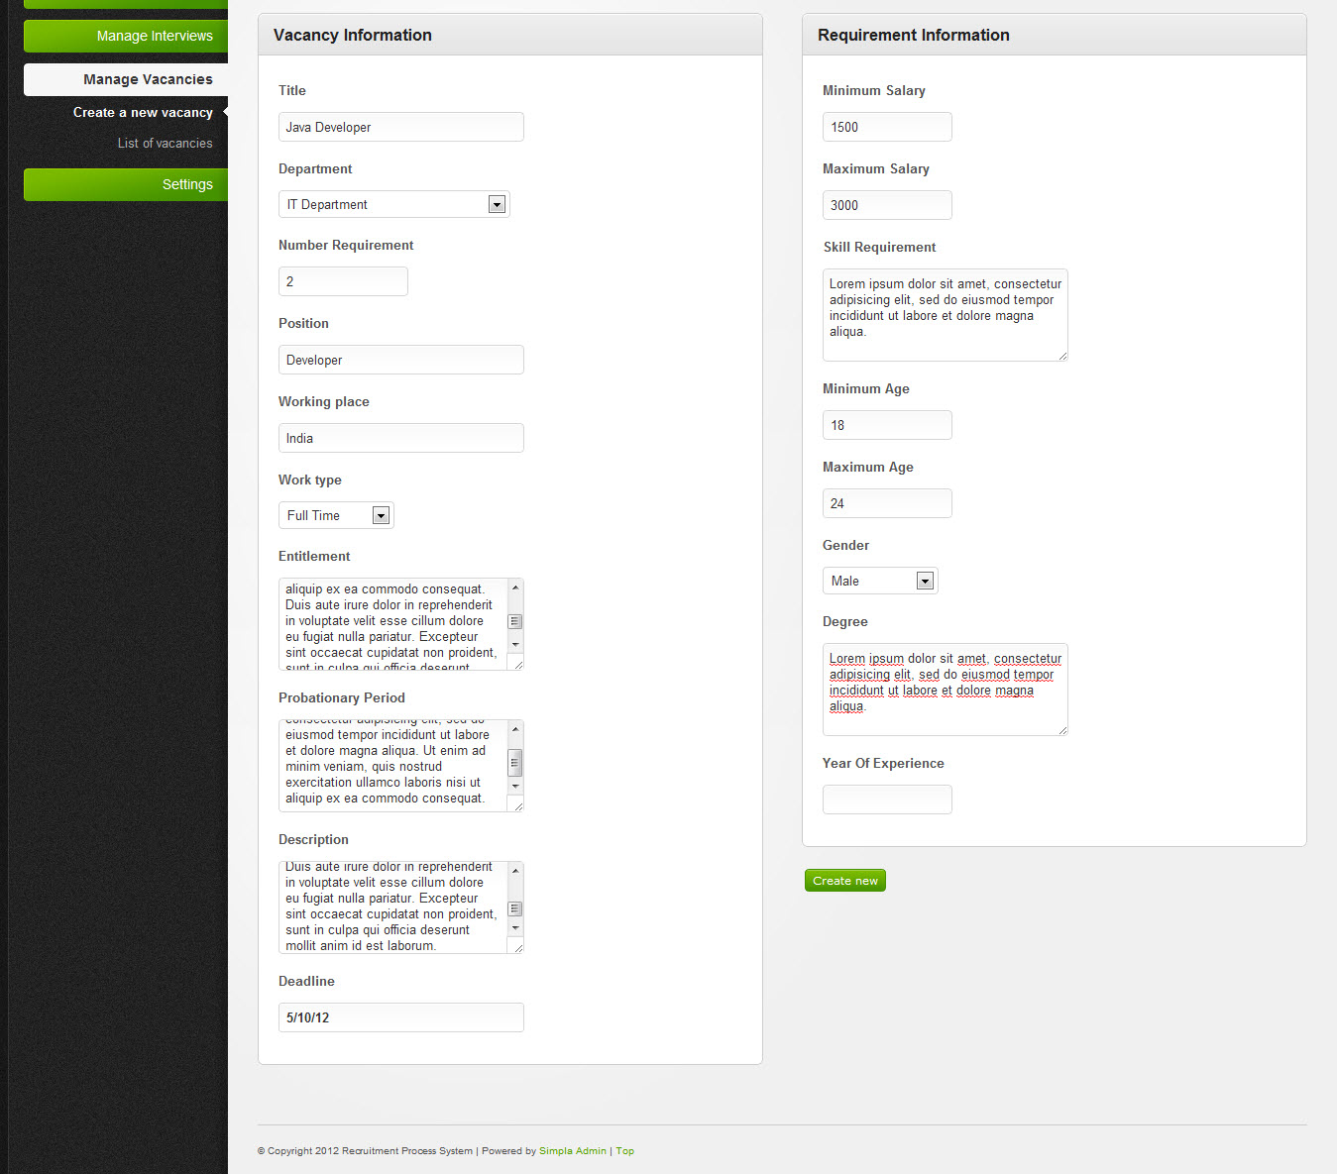

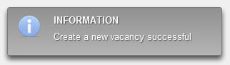The notification will be displayed when done

1. Create applicant

Click the icon to do function ”Create Applicant”

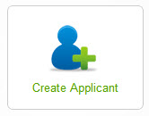

Validate form if the data is invalid

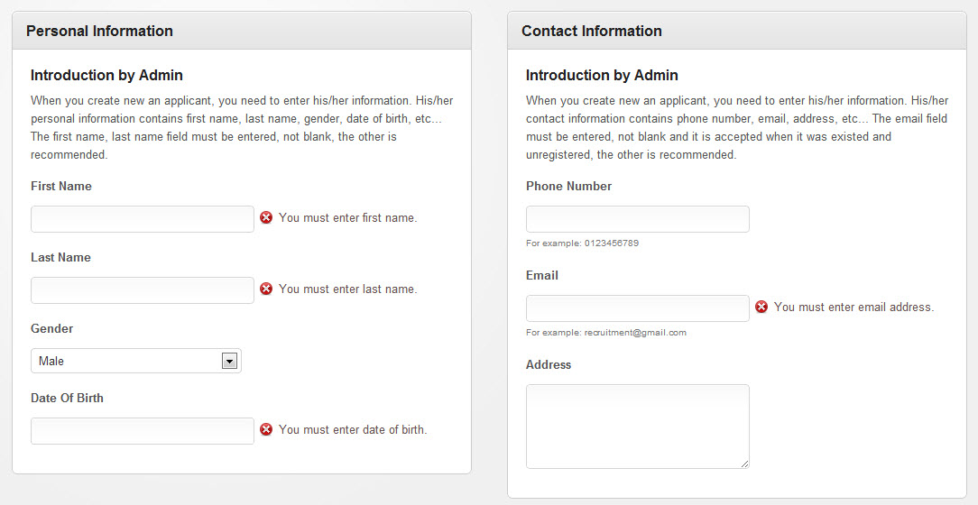

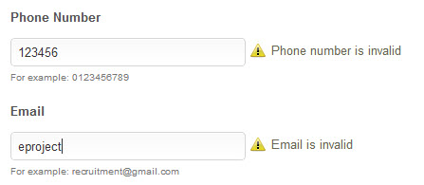

Check email

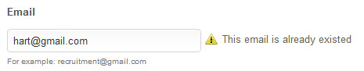

Click to Attach link to do function attach in the create applicant form

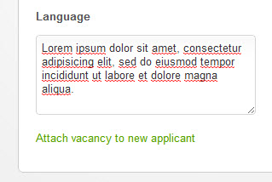

1. Attach vacancies

Attach form will be displayed, you can use “Attach” button to attach the vacancy for applicant

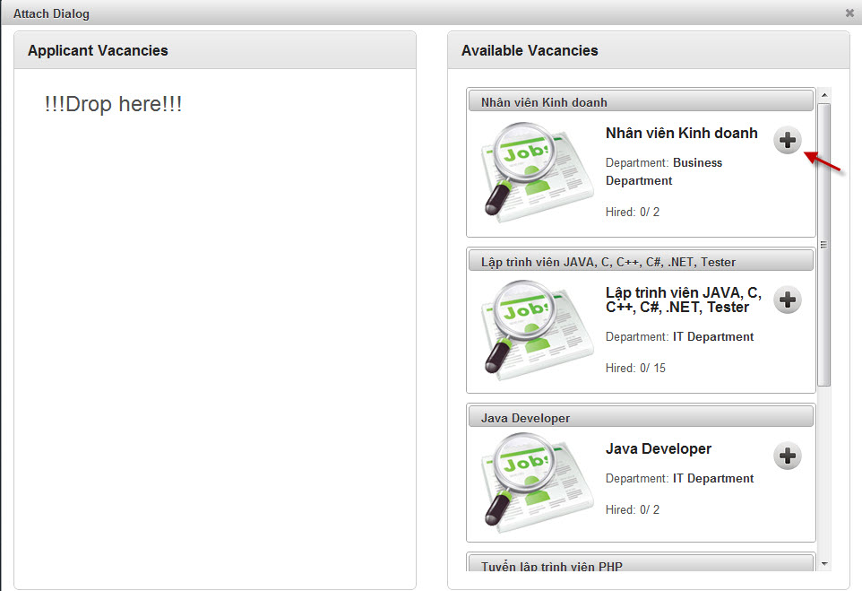

Or using “Drag and Drop” to do this

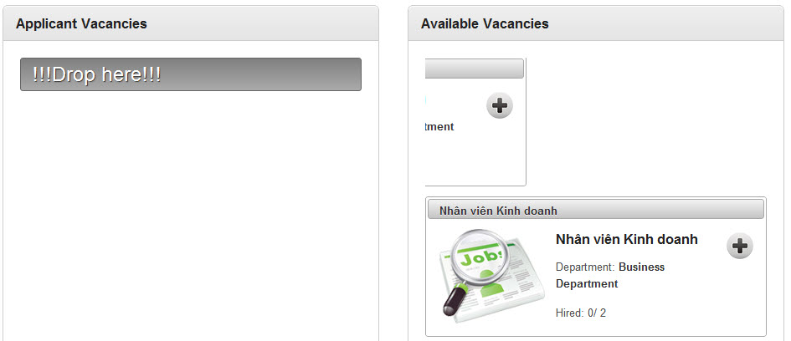

You can detach the vacancy by click to “Detach” button

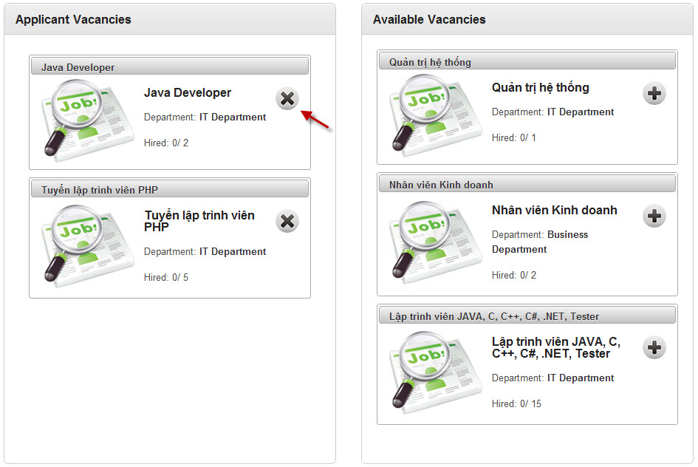

After attached, the number of attached vacancies will be display

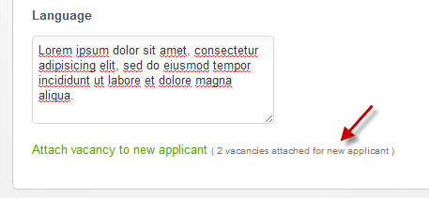

Beside, you can do this function by click to “Attach Vacancies” icon in the quick menu bar



The same UI as attach form in create applicant form, but it contains the combobox to select an applicant

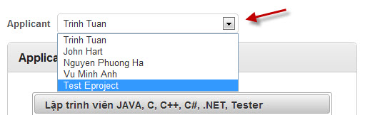

Select someone and list of vacancies will be display, you can detach it

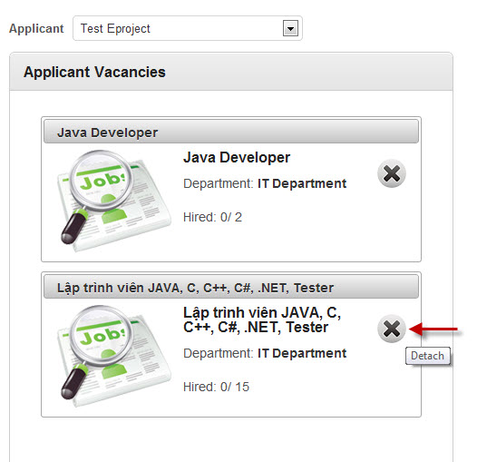

1. Create interview

Click to the “Create Interview” icon to do function “Create Interview”



You must chose the date and time to schedule interview

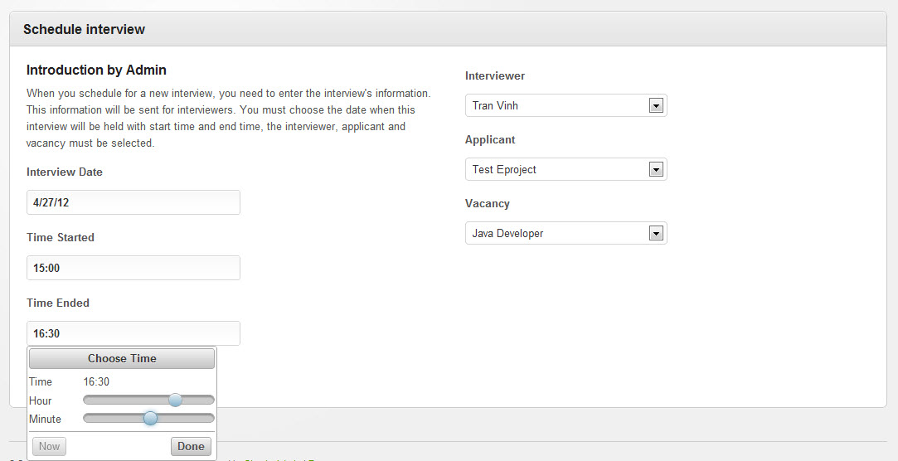

If the interviewer or the applicant had been schedule in this time that you chose, the notification, the alert with “View conflict schedule” icon will be displayed

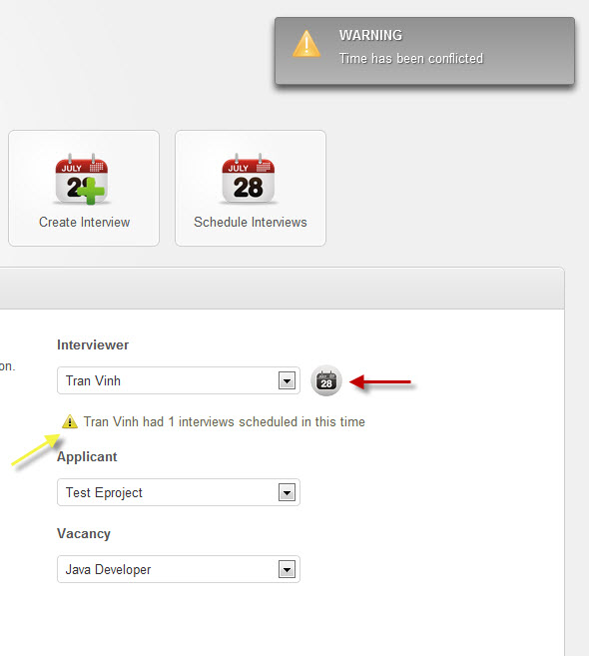

You can view the schedule that was conflicted by click to the icon

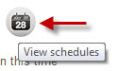

And the dialog displayed

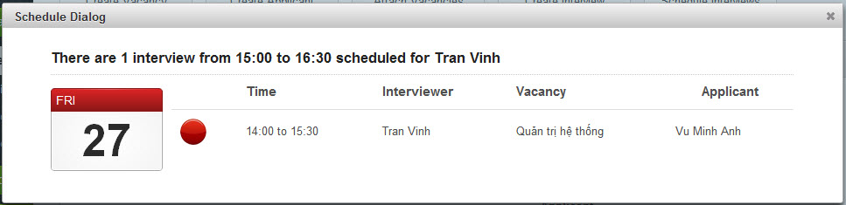

After created successful, the form will be rendered again

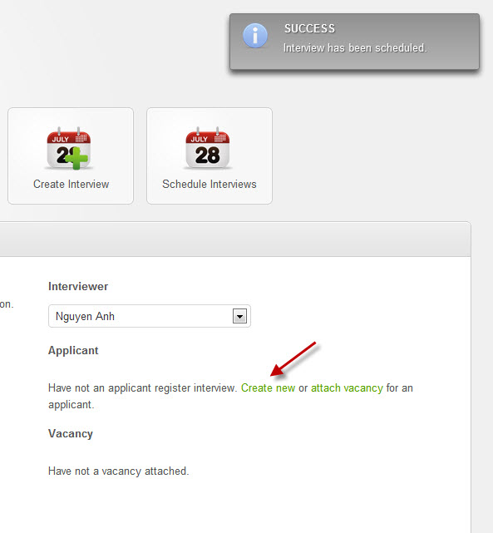

1. View all schedules

Click to the “Schedule Interviews” to do function “View all schedules”



The schedules will be displayed

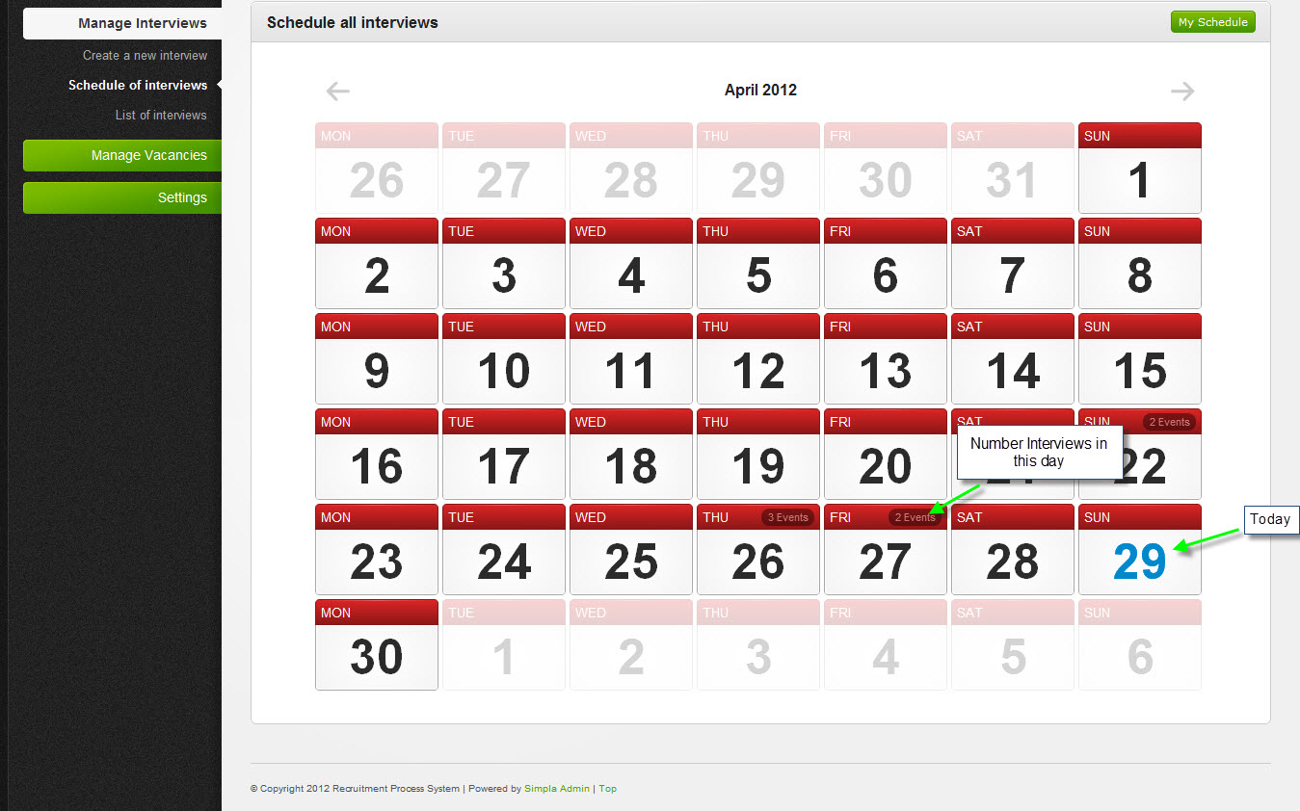

Click to any calendar to view interview schedules in this day

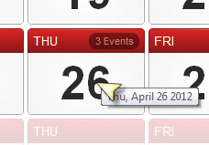

And the dialog displayed, you can change time for this interview by click to the icon “Change Time”

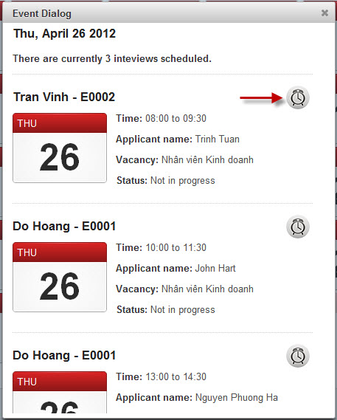

1. Select/ reject interview

You must login with the role is **interviewer** to do this function, when you logged, screen will be displayed all of the interview of this account that are in progress

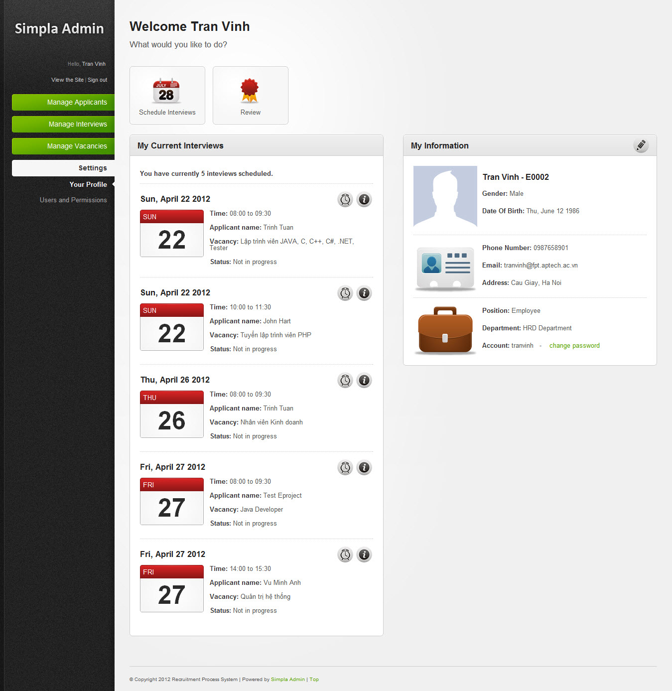

Click to the “Information” to select or reject the interview

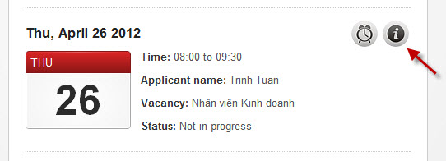

And the form will be displayed, you must chose status for this interview

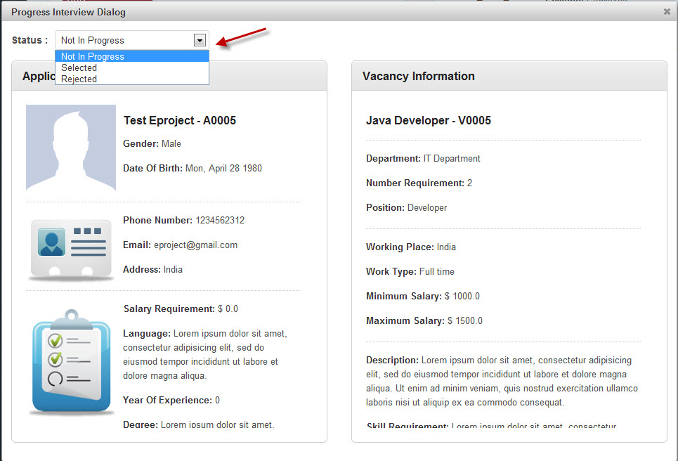

Selected interview

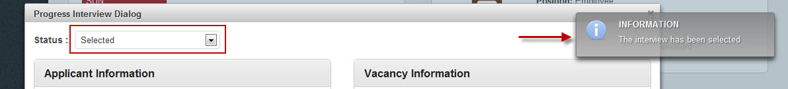

Or rejected interview

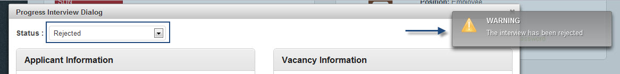

Some results

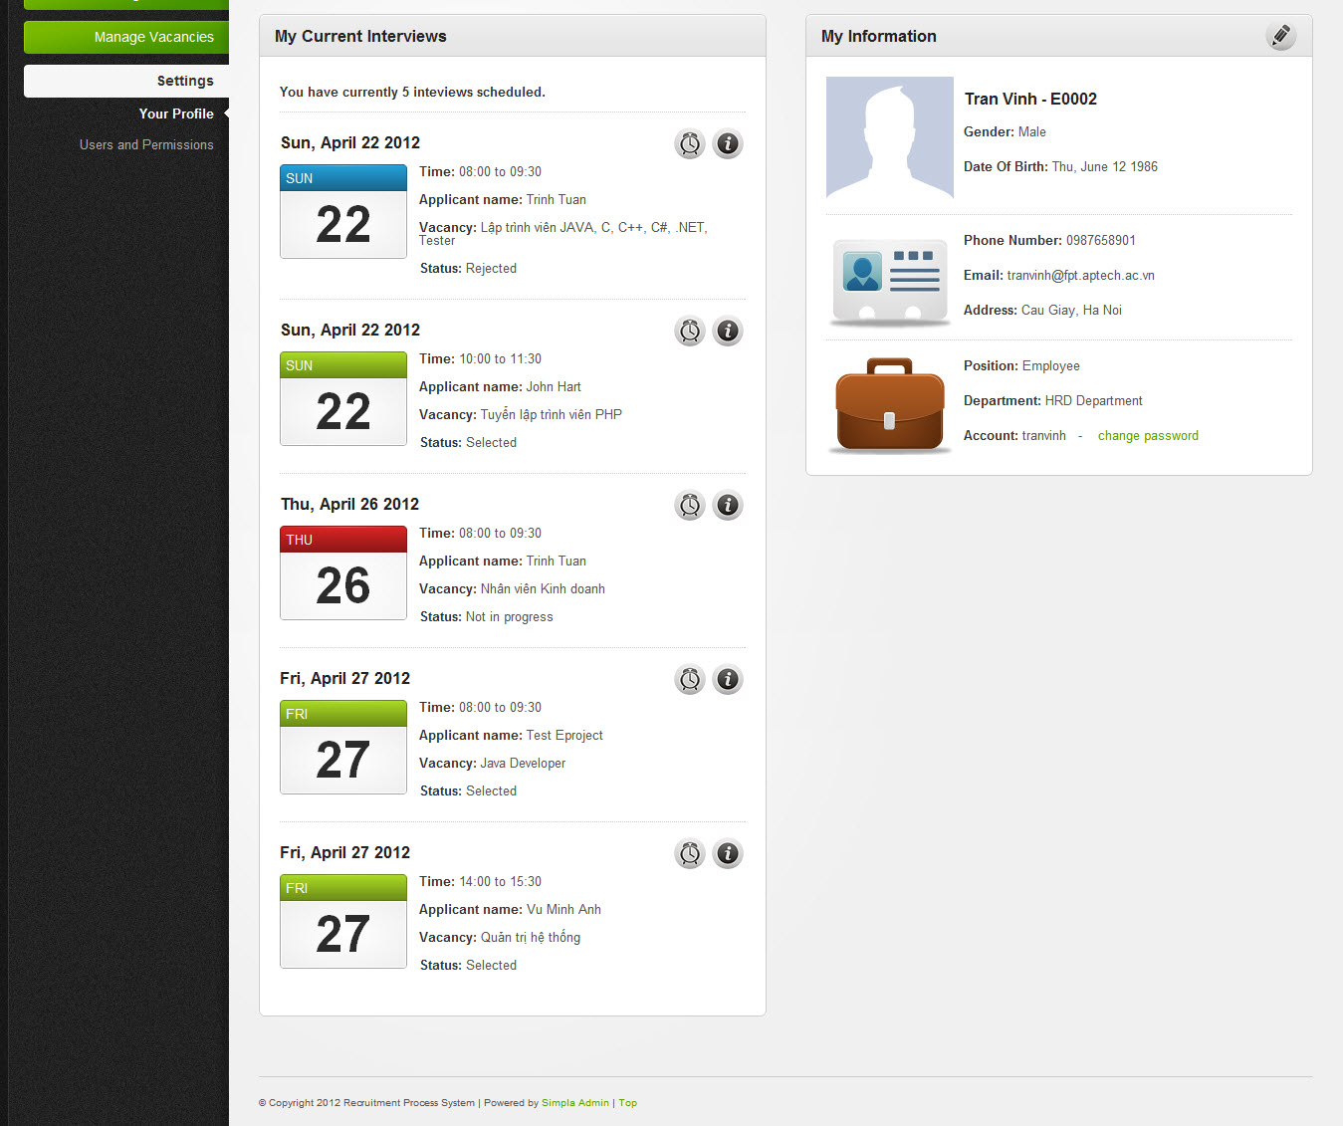

1. Review interview

Click to the “Review” icon to review interview

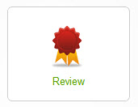

If the interview is selected, you can review the interview. Click to the “Review” icon

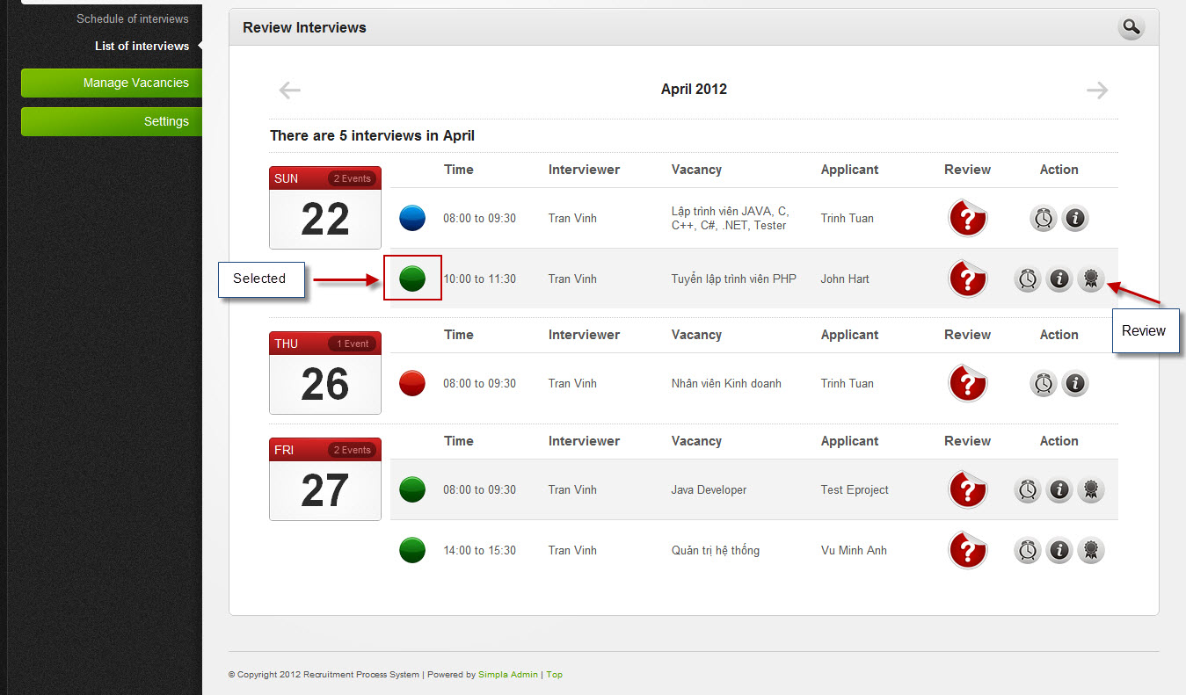

And the dialog will be displayed

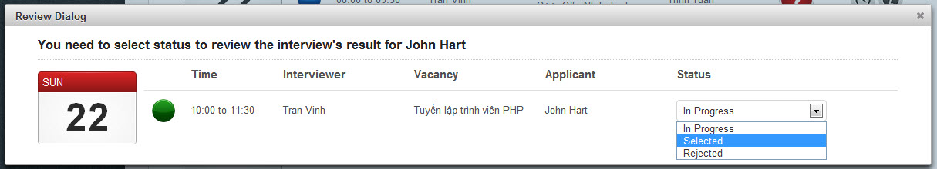

Select one and press “Review” button to finish

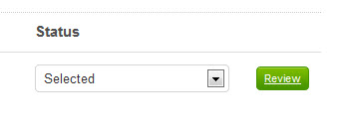

The confirm dialog will be display

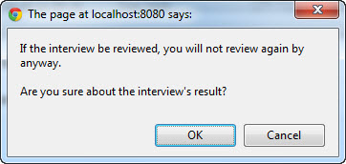

If you chose OK, the interview will be not review again.

------------------------------------------------------------------------------------------------------------------------------------------

**Because the time is limited, we can’t introduce all of the functions that we made. We are very sorry for this inconvenient**